17. Develop a system using UML for Vehicle Registration Number Registering System. The owner should apply with the documents and pay the fee, once the documents had been accepted and the vehicle is verified. Then the document for registration is issued by the system.

ACTIVITY DIAGRAM:

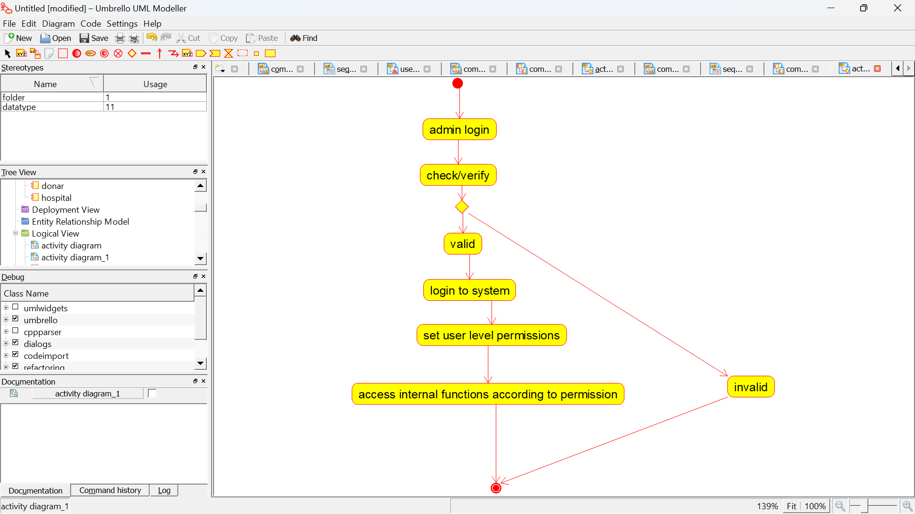

PACKAGE DIAGRAM:

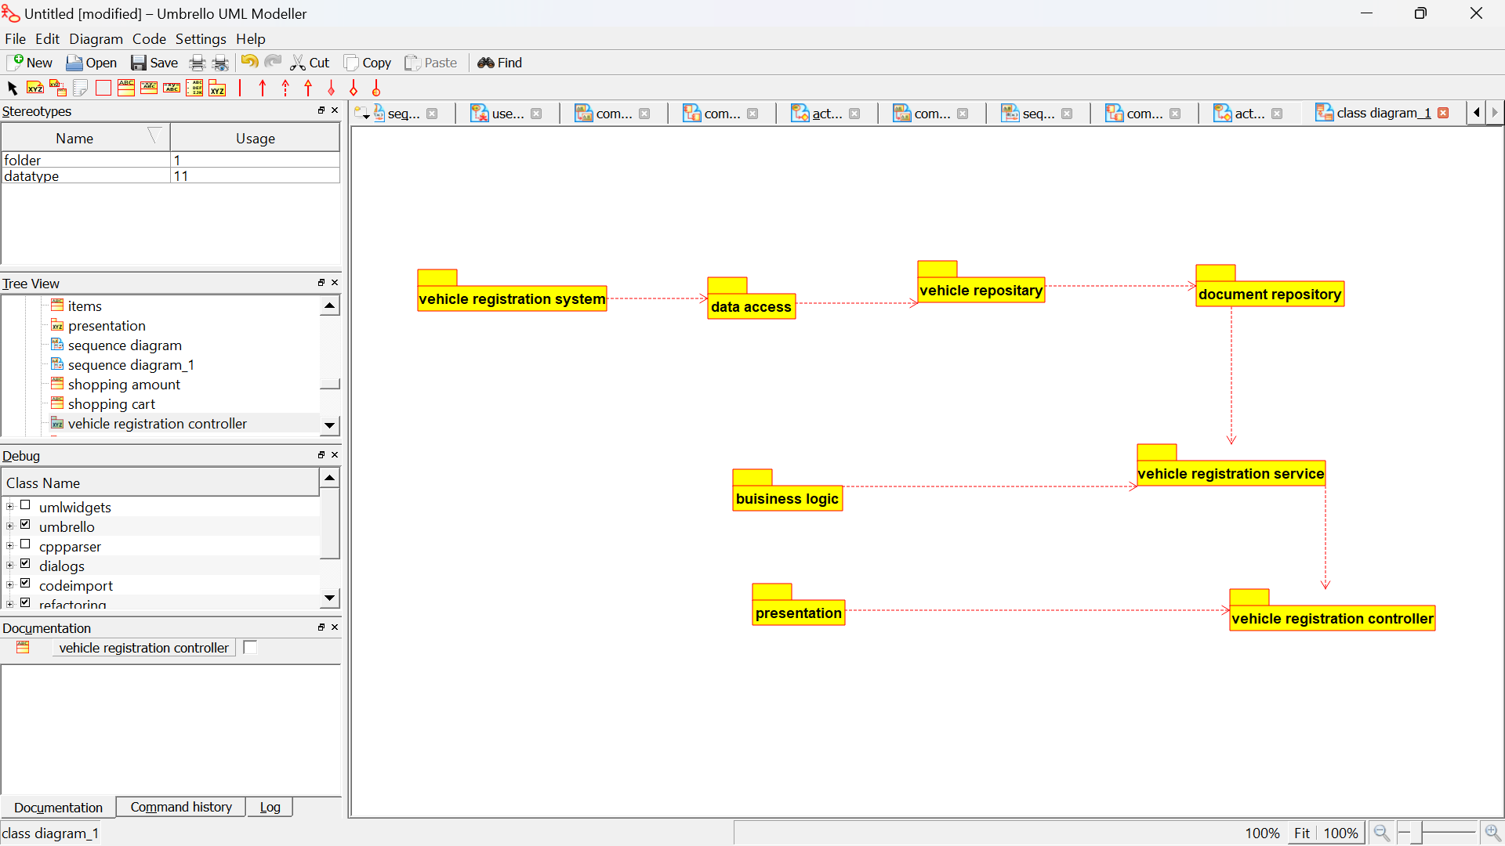

SEQUENCE DIAGRAM:

